- How does Fast Clock work?
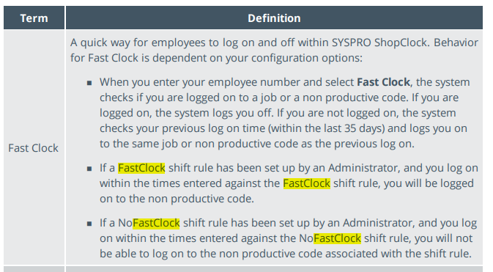
- Does Payroll use Fast Clock entries or when employee logs onto an actual job?
- Jen

- Do all the PCs have operational scanners or do employees have to manually type their EE#, job # etc.?
- Yes, unless otherwise told so.

Would like to obtain a list of all the NP codes/descriptions
- 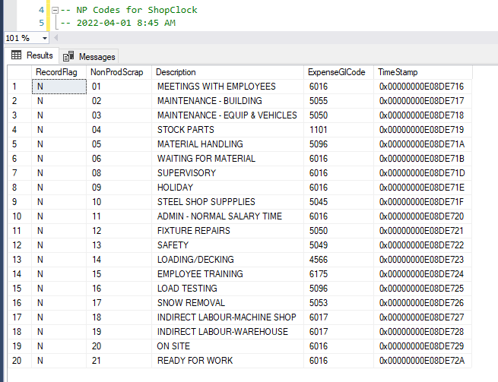

4. Is it necessary to scan/enter an Operation & Machine code on 10M jobs?
- Yes these are mandatory syspro fields.

Icon

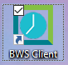

Job Log on
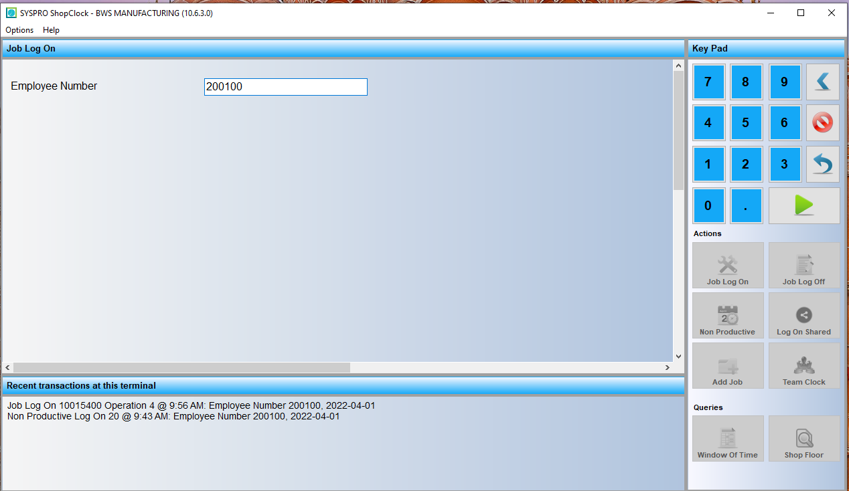

Enter Job #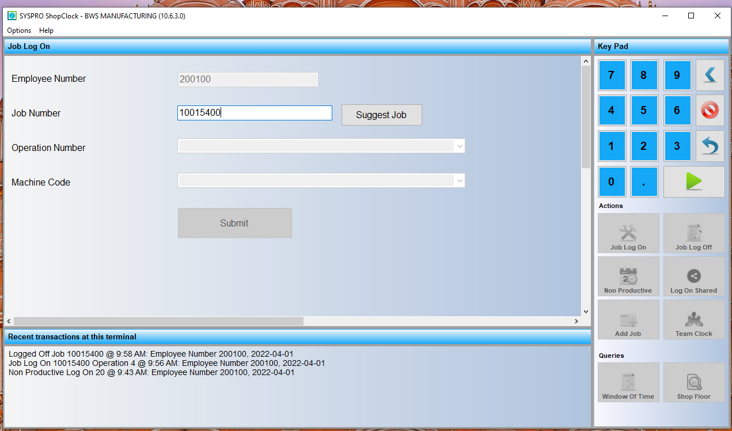
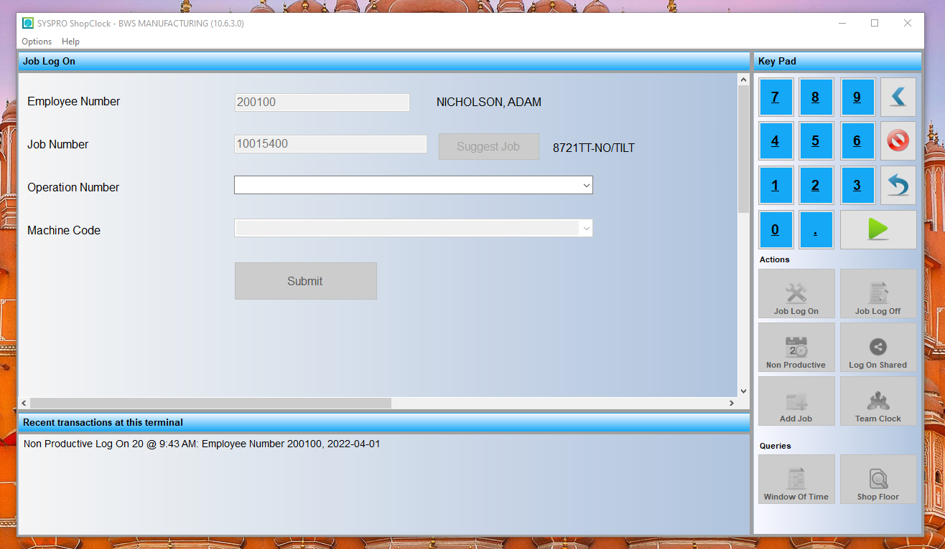

Select Operation: 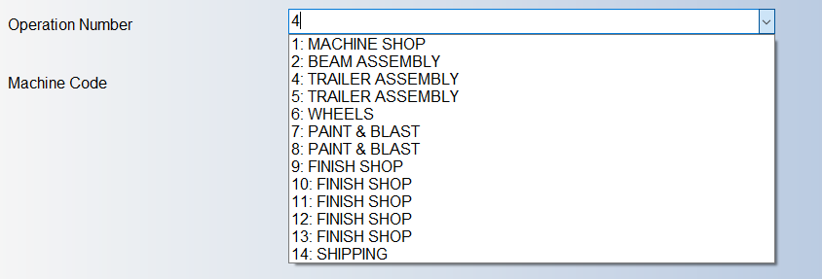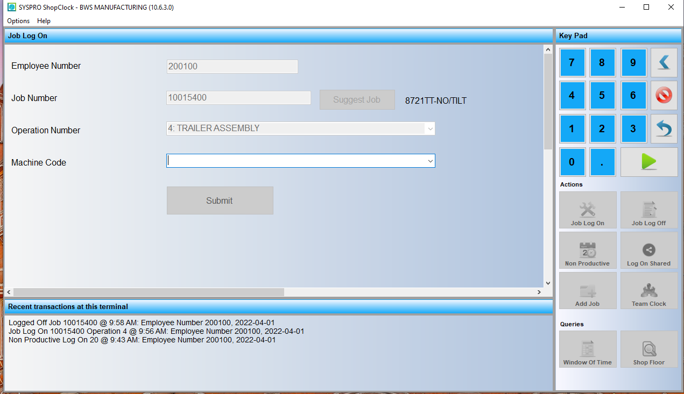

Select Machine:
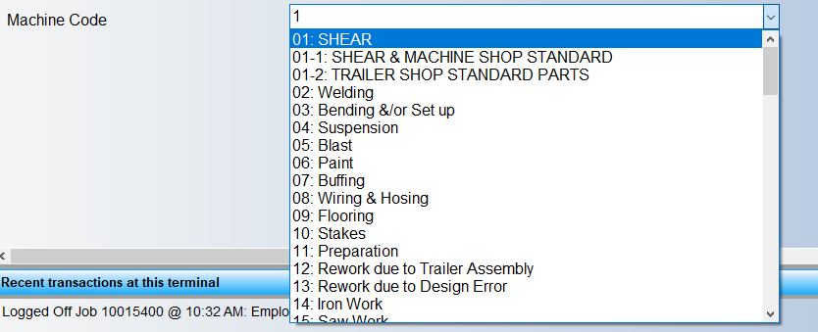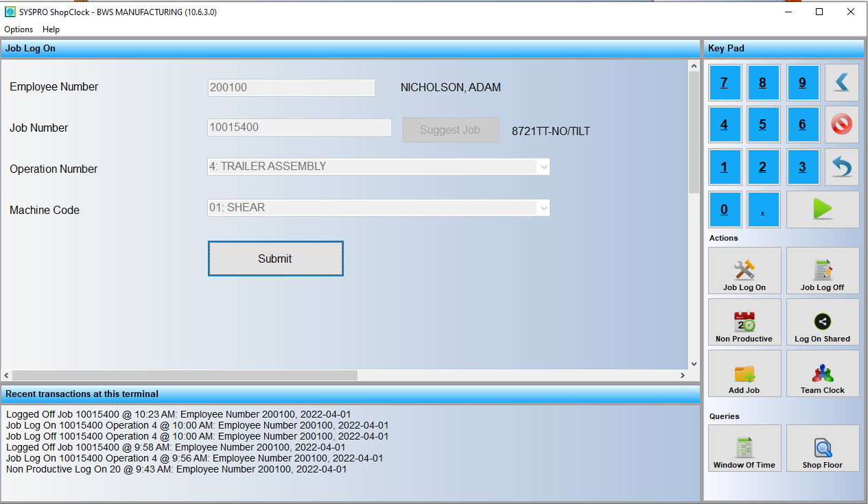

Success!
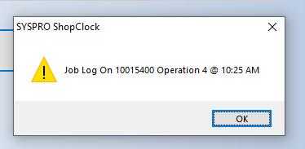
Job Log Off:

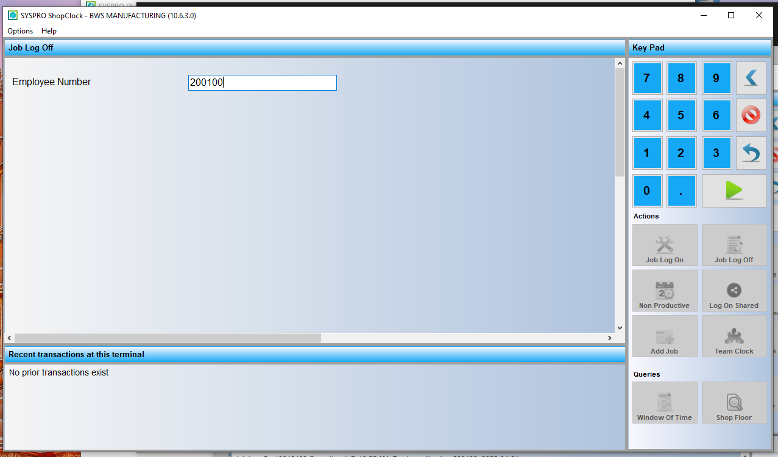
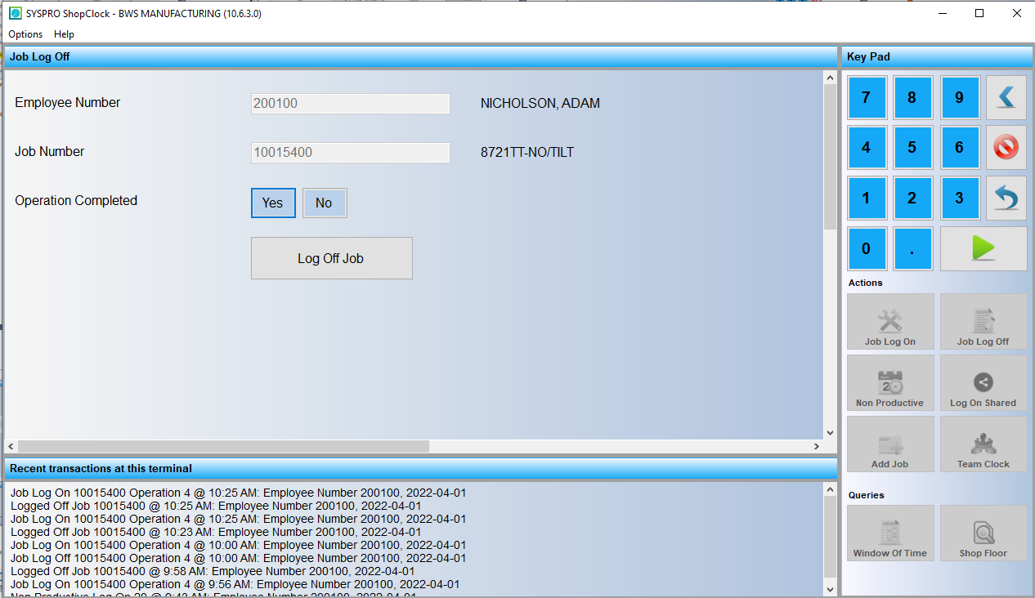

Success!
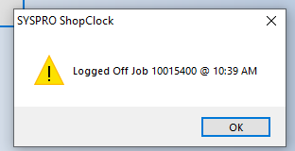

Already signed in:
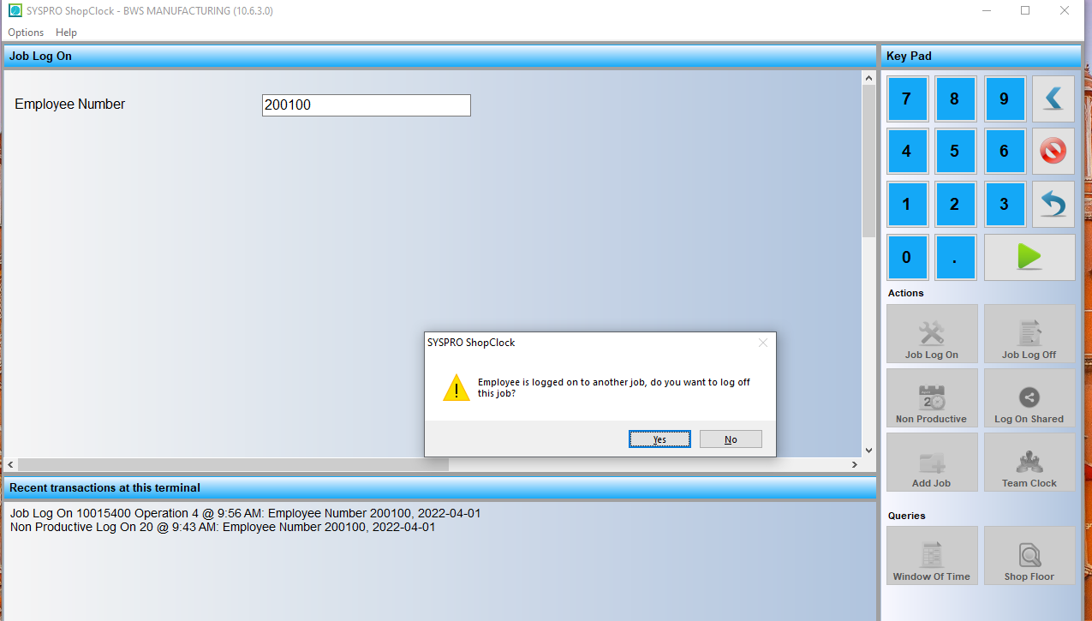

Job Log
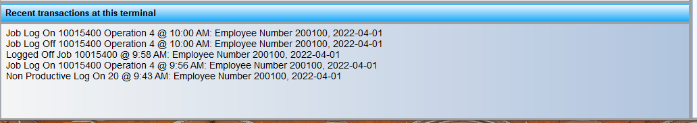

Scanned job that is already complete
